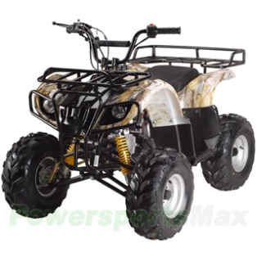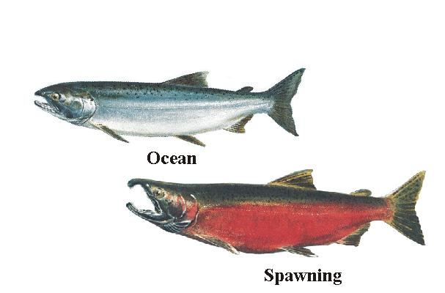

|  |  |
| --- | --- |
|  | **Wasilla Soil and Water Conservation District**  5751 E Mayflower Ct. Wasilla, AK 99654 |

Presenting an

**ATV/Salmon Stream Crossing Construction Workshop**

Audience: Professional, Government recreation/trails/lands/planning staff, resource conservation agency personnel, riders, retirees, commercial/volunteer group trail builders, ATV distributors, students, educators, State legislative aides.

Purpose: To introduce & educate people to the intricacies of assessing & constructing fish- friendly ATV trail salmon stream crossings. The intent is to:

1. provide factual knowledge of salmon biological basics & stream crossing impacts;
2. define/explain state rules regulating salmon stream crossings;
3. present a “state-of–the state” on present crossing conditions, discussion of present education outreach & needed priorities for constructing crossings;
4. unveil a newly engineered ATV bridge design;
5. offer detailed “mechanics” of selecting & constructing appropriate crossing improvements/options – an illustrated manual will be issued.

Training Content: Qualified presenters/practitioners will focus on providing factual salmon & stream basics/characteristics; ADF&G rules & regulations/permits; local rider input, user interview survey results regarding the rider’s perspective toward fish crossings; assessment of crossings in the Mat Su Core area; technical crossing construction tutorial – assessment, soils, techniques, structures, & options.

Presenters: Mike Bethe, Manager & Sarah Wilber, Biologist (Palmer ADF&G office); Mike Campfield, P.E. MSB Environmental Engineer; Mike Shields, nationally known trail builder, consultant extraordinaire; & Chuck Kaucic, ATV/Salmon Stream Crossing Assessment & Outreach Project Manager. USFWS staff have been invited to present; however, have not confirmed as of the release of this invitation.

Session Options:

1. Wed. March 18, 9 am - 5pm, Mat Su College Rm 202 FSM Bldg
2. Sat. March 21, 9am - 5 pm, MSC Rm 103, FSM Bldg

NOTE: The College Cafeteria is conveniently open on Wed 3-18 to offer lunch service.

Sessions are *FREE* & are limited to 25 participants (first-come, first-registered basis)

REGISTRATION: Contact Chuck Kaucic, District Manager, Wasilla Soil & Water Conservation District, [distmgr@wasillaswcd.org/](mailto:distmgr@wasillaswcd.org/) 357-4511

*Funded by the Matanuska-Susitna Borough, John Moosey, Borough Manager*

CONSERVATION – DEVELOPMENT – SELF GOVERNMENT